Report and Consent for Building Over Easement(s)
Building Regulations 2018
Reg. 130 (1)

Applicant Details
I/We

Of (address)

Telephone No Email

Being the owner(s) of the land described hereunder hereby request consent to construct, erect and/or retain the building and/or structure described hereunder over the works of the Council easement hereunder subject to any Conditions required by Moorabool Shire Council and as set out on the back hereof.
Property Details
The following details will be on your Property Title. Alternatively you can get this information from the Land Channel, at https://www.landata.vic.gov.au/tpc/

Street
- Number

Town/Suburb Lot Number

LP/PS Number
- CA Number

Sec. Number Parish Dimensions
Frontage Depth

Situated on the
(Insert direction - North, South, East, West)
side of street

Locality Plan:
Indicate the position on the land of the proposed building or structure and the position of the Council works and or Easement.
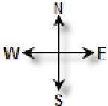

Description and Dimension of Building and/or Structure (must include floor type)

Please provide the following supporting documentation*
1. Current certificate of title, plan of subdivision and any covenant details (Not more than 1 month old) | ◻
2. Scaled drawings showing the site plan, structure and its footings proposed to be constructed and position relative to easement | ◻
3. Written consent from Other Reporting Authority– Water, Sewer, Gas, Electricity, Telecom etc. within the easement (if applicable), for example sewer or water mains (Western  Water in Bacchus Marsh and Central Highlands Water in Ballan) or telecom cables | ◻

Conditions for permit to build over stormwater pipe/easement
Permit issued in so far as Council’s rights are concerned, subject to the following conditions:
- That other Authorities with utilities/assets within the easement are notified of works to be undertaken.
- You permit Council to enter into and upon the building or other structure and/or the easement for the purpose of inspecting, constructing and maintaining or repairing any drain or other works of the Council now laid or which may be hereinafter laid by the Council.
- You be solely responsible for all injury, loss or damage which may be occasioned to the said building or other structure by reason of or incidental to the carrying out of the inspection, construction, maintenance or repair of the said drain or other works of the Council or by reason of or incidental to the presence of the said drain or other works of the Council.
- You indemnify the Council against all actions, claims, suits and demands arising out of or incidental to the erection and/or retention of the said building or other structure over the said drain or other works of the Council and/or the said easement.
- You pay the Council any additional costs incurred by it in inspecting, constructing, maintaining or repairing the said drain or other works of the Council by reason of the said building or other structure having been erected over such drain or other works of the Council and/or the said easement.
- Not to sell or mortgage land to which this Consent refers without first disclosing the contents of this Consent being granted.
- You meet the costs of any alterations Council may make to its drains, or manholes as a results of this Consent being granted.
- You accept responsibility either now or in the future, for the relocation of any private house drains or other works of the Council that are located underneath the proposed building.

Note: This Consent does not constitute a building permit or permit under the Planning and Environment Act for the use of land for any purpose not in conformity with any Interim Development Order or Planning Scheme made pursuant to such Acts and does not absolve the person to whom it is give from complying with any Statute of Regulations made thereunder and particularly with the Building Code of Australia, Victoria, any applicable Municipal By-Law of the provisions of any Planning Scheme or other Interim Development Order affecting the land.

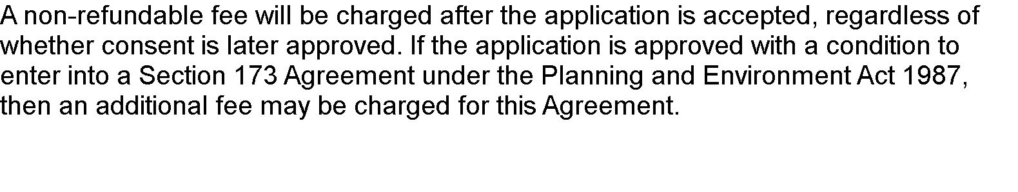
The application fee is $180. This is application fee is non-refundable even after initial assessment the case will be refused. Please also note, if the application is approved with condition of section 173 of Planning & Environment Act 1987, the other application charges are included. Should you required further details, please contact Council’s Planning Unit.

This Personal Information is held by Moorabool Shire Council in accordance with the Privacy and Data Protection Act 2014

Signature of Owner(s)
Dated this
 | day of
Please note: | Personal information will be held securely and will not be used or disclosed for any other purpose

