Commercial Business Community Group

- Applicant Details

Surname:_____________________________________ Given Name:______________________________

Business Name:__________________________________________________________________________

Physical Address of Business:_______________________________________________________________

Postal Address:__________________________________________________________________________

Telephone No:___________________________________ Mobile No:______________________________

Email:__________________________________________________________________________________

- Placement of the following items (Please tick the type of item/s you are applying for).
A-Frame Sign/Teardrop Banner Outdoor Heater
Chairs & Tables Goods Display
Charity Clothing Bin Barrier Screens
Planter Boxes Real Estate Pointer Boards
Temporary Food Stalls or
Sausage Sizzles Other Specify: ______________

- Details of item/s

- Item : _____________________________ Location: ______________________________________
(e.g. 4 x chairs & 2 x tables) (e.g. Street/s & Suburb)

- Item:_____________________________ Location: ______________________________________

- Item: _____________________________ Location: ______________________________________

A Frame Commercial | $ 239.00
A Frame Commercial (Temporary Event Signage) Max 10 days per year 3 signs maximum | $ 81.40
A Frame Community Group | $ 22.70
A Frame Community Group (temporary event signage) Max 10 days per year 3 signs maximum | No Charge
Additional A Frame Sign (Community) per sign | $ 11.80
A Frame Election Signage Council Fee Per Permit | No Charge
Outdoor Dining application fee | $ 239.00
Outdoor Dining per square mt or part of if over 3m2 | $ 84.50
Use of footpath /storage of items per square mt or part there of | $ 84.50
Use of Footpath for community, religious or political event/stall/fundraiser | No Charge
Note commercial operators can pay a single application fee for an application for foot path dining and advertising signage for the same property.

- Additional information (if applicable): ____________________________________________

_______________________________________________________________________________

_______________________________________________________________________________

Consent to Utilise Neighbouring Premises Footpath Trading Zone

Physical Address of Business: _______________________________________________________________

Telephone No: ___________________________________ Mobile No:______________________________

Email: __________________________________________________________________________________

Neighbouring Business Name: _______________________________________________________________

Business Owner Name: ____________________________________________________________________

Signature of Consenting Business Owner: ______________________________________________________

- Application Checklist

I have signed this application

I have provided a scaled drawing indicating the layout of items
to be placed on Council land

I have submitted photographs or design details of the items
I propose to place on Council land

I have attached a copy of my public liability insurance

Failure to include all items in this checklist may result in delay or denial of this permit.

Note: Advertising boards, banners and barrier screens must meet advertising and colouring standards set out in Council’s Footpath and Activities Guidelines 2021. A photograph or diagram of these items including colour scheme must be provided with this application.

- Permit application layout plan (please complete)

Total m² of footpath utilised: ______________________________

Notes: You are required to show to scale the following:
- The area to be occupied by tables and chairs and any other fixtures or fittings;
- The building line and/or shop front including side boundaries, doors, windows etc;
- The footpath width to face the kerb, any existing street fixtures or fittings and pedestrian thoroughfare; and
- The direction of North on the sketch drawing.

See attached example

I have attached a copy of current Public Liability Insurance showing coverage of $10,000,000 (minimum).

I ___________________________________________ (please print) understand that the information provided above will be used in accordance with relevant legislation and Council Policies and declare that this information is true and correct.

Signature ______________________________ Date ______________________________
Please Note: Personal information will be held securely and will not be used or disclosed for any other purpose.

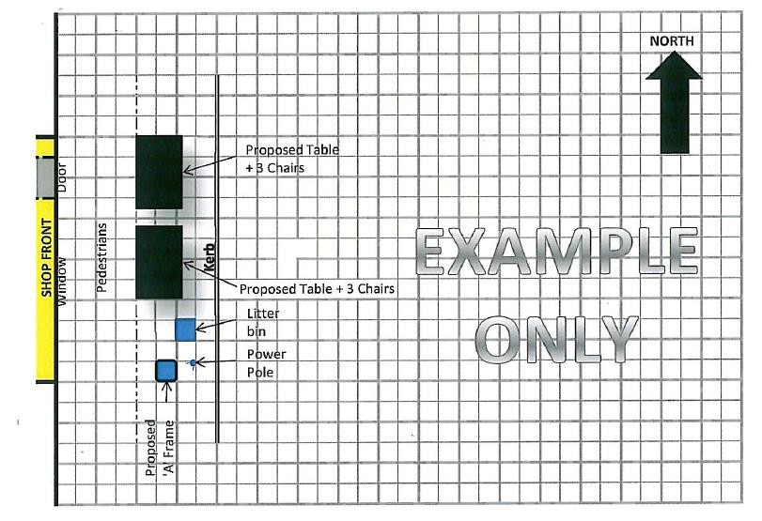
EXAMPLE LAYOUT PLAN
1.2m
3.6m
1.8m

